# MonkeyDart WhitePaper

## The quintessential Sh*tCoin

## Table of contents:

*Abstract*

*Background*

*Mission Statement*

*Roadmap*

*Risks*

3

4

5

6

7

## Abstract

Wow. You’ve made it this far. Congratulations!

To make it easy to copy paste this abstract into your intellectual write-up about how “this coin is a top-ten in 20xx” and why “it’s the most under-valued coin right now”, here’s a link:

[*https://www.reddit.com/r/CryptoCurrency/submit?selftext=true*](https://www.reddit.com/r/CryptoCurrency/submit?selftext=true)

Meanwhile, this coin serves probably the least amount of purpose possible for an ERC20 token created in the middle of the night by a redditor.

It’s just shit coins all the way down.

This coin is a reminder of the nature of CryptoCurrency Investments.

How Coins with amazing tech can lag behind in a market that consists of coins in the top-ten with no working product, mainly because the price is sub $0.25 even though the circulating amount is in the Billions.

“Dumb money lines the pockets of Smart money”.

Life is pain.

But there’s hope!

By hodling this coin, you can contribute to this problem. Because, we all need a good meme-coin in our life.

## Background

Yeah. Umm, like I said.

Just shitcoins all the way down.

## Mission Statement

Here at MonkeyDart Incorporated (very much not real), we firmly believe that:

The beauty of coins is on the inside.

It doesn’t matter what working tech you have, or how much effort you’ve put into your product, any rando on the internet can throw something together over night that will probably have a higher market cap than yours!



## Roadmap

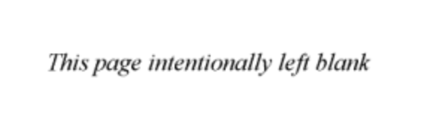

Nope! Nothing here. Surprised you’re still reading at this point though.

+/u/dogetipbot 10000000 doge

## Risks

Disclaimer:  
This coin could completely lose all value overnight. Or it could overthrow Bitcoin and crash CoinMarketCap.

Such is the way of life.

Whoops. I guess this page has some yellow on it.

Looks like it’s not completely a White Paper then!

Ayyyyyyyyy I’m so lonely